Module – 3

Experiment – 3

Write a program to communicate between client and server using UDP.

**Client Request**

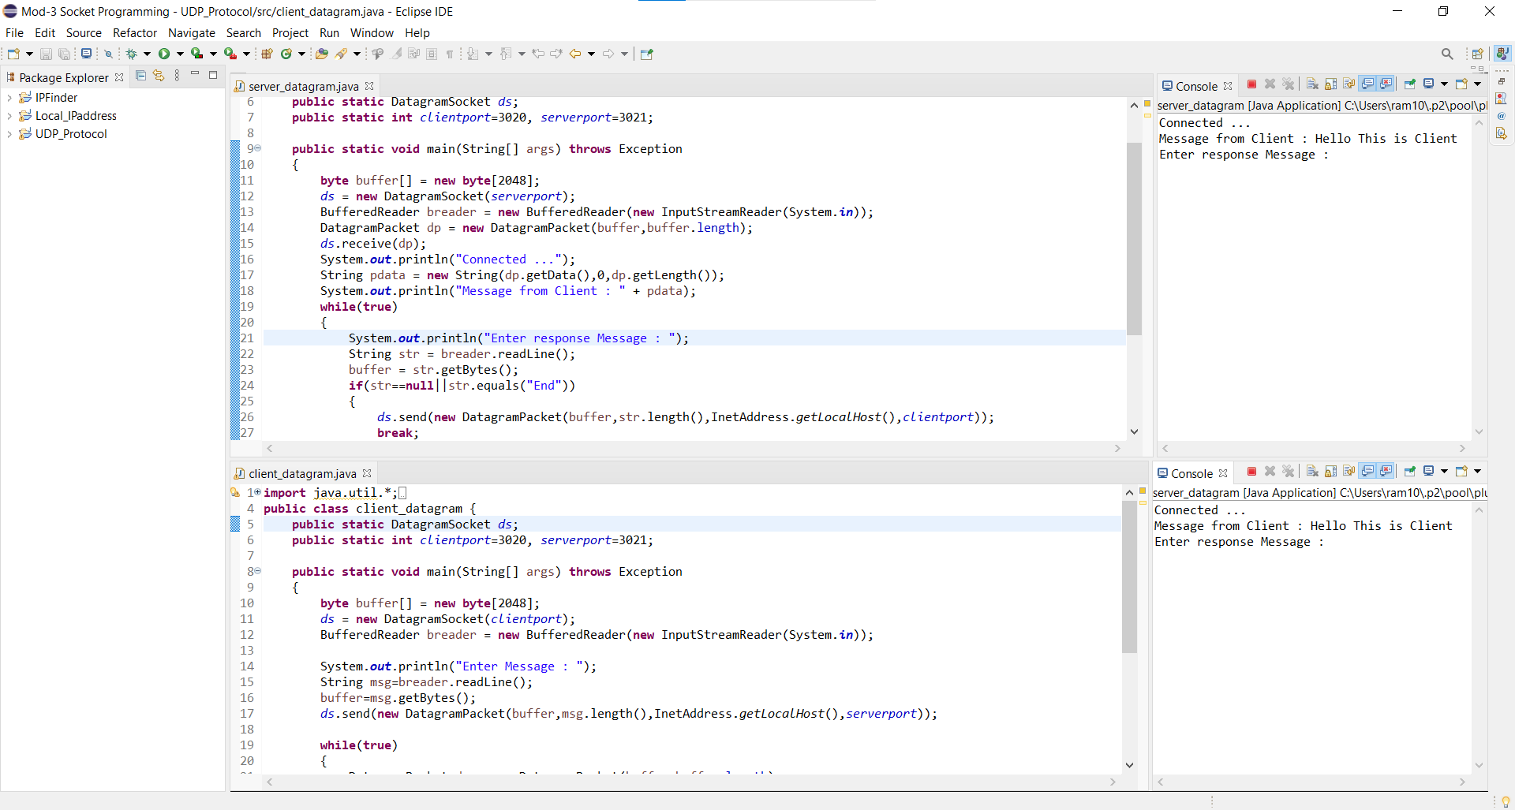

**Server Response**

